WE’RE GONNA FOLLOW THIS BLOG/TUTORIAL:

Face Recognition:

<https://www.hackster.io/mjrobot/real-time-face-recognition-an-end-to-end-project-a10826>

Installing OpenCV:

<https://www.pyimagesearch.com/2017/09/04/raspbian-stretch-install-opencv-3-python-on-your-raspberry-pi/>

=====================================================================================

FIRST:

1. Download previous version of Raspbian (Raspbian Stretch) from <http://downloads.raspberrypi.org/raspbian/images/> (1+GB, 20 min depending on internet speed)

DOWNLOAD THE LATEST STRETCH VERSION <http://downloads.raspberrypi.org/raspbian/images/raspbian-2019-04-09/> so that we don’t have to mess with updates & upgrades

2. Download balenaEtcher <https://www.balena.io/etcher/> to easily flash your zipped Raspbian file to the SD Card you want. (You need to have a SD card reader or USB SD card reader).

3. Make sure your SD Card is empty and also at least 16GB.

(fully reformatted mine as I had Raspbian Buster on, took slightly more than ½ an hour for it to get done QUICK FORMAT would be faster)

Now let’s flash: (Choose zip file, and USB Drive (mind was auto chosen), and click flash), it will ask you to allow stuff just say yes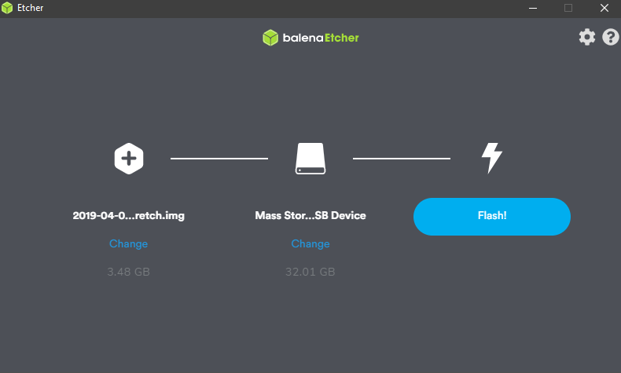

it finished in 10+ mins for me.

Next let’s get our arducam set up:

You want open up your Arducam and install the heat sinks behind the LEDs like this

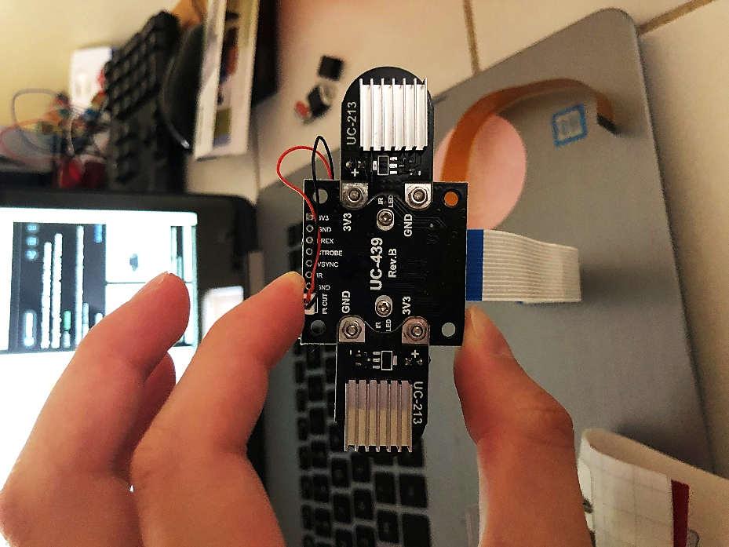

Now let’s install it to the RPi, by lifting the black plastic part out of its original position, so that its kind of slanted:

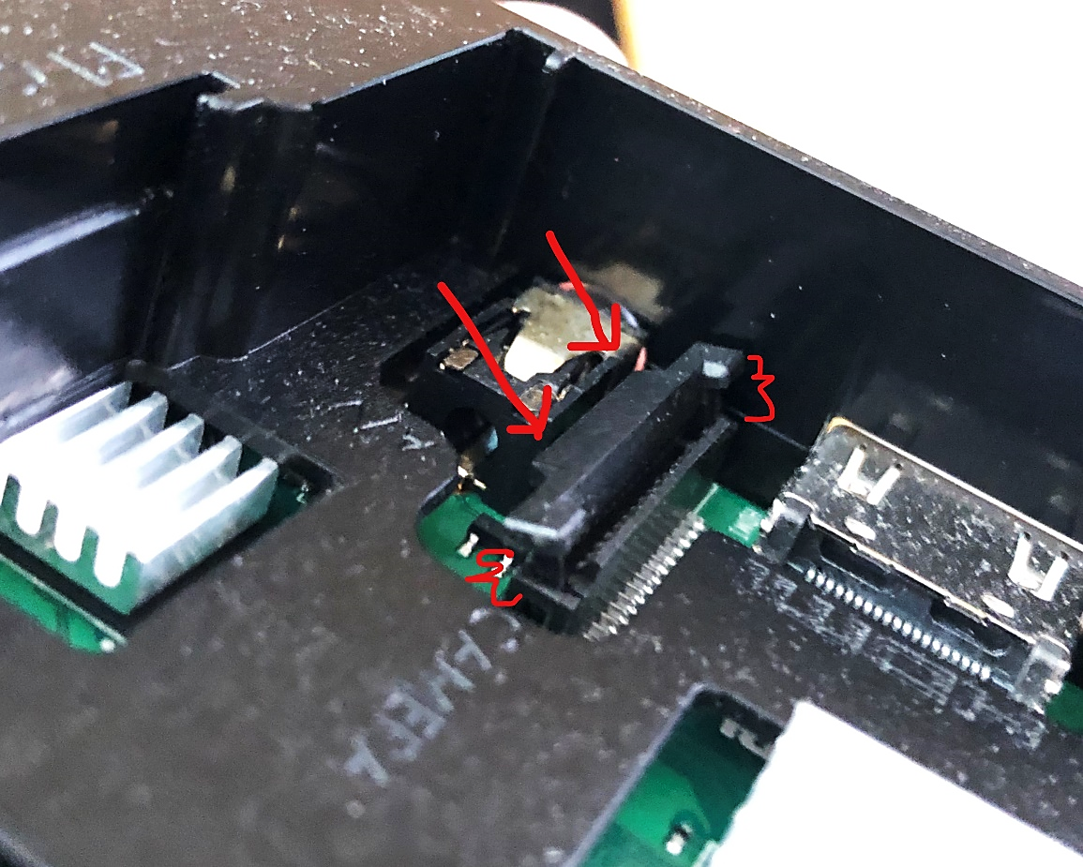

Now make sure its you slide the ribbon into the RPi securely, it will still feel loose since we did not push the black plastic back down

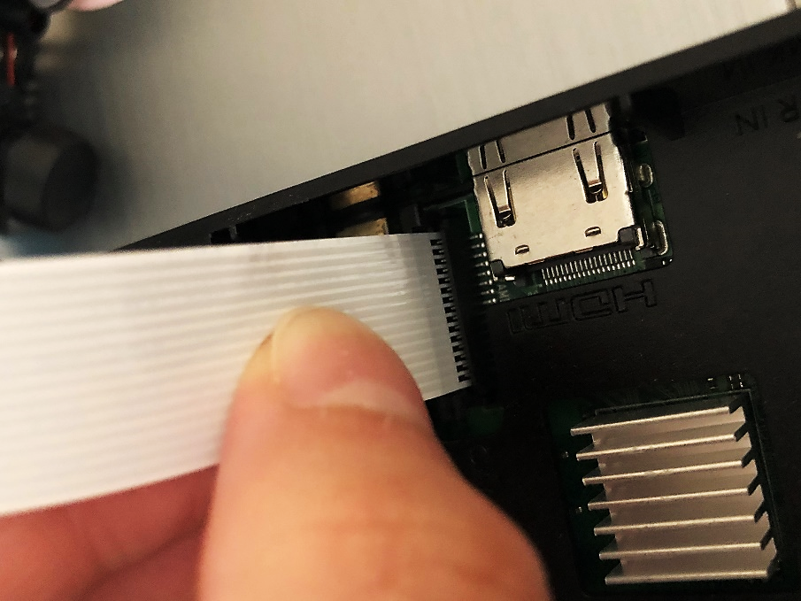

while holding the ribbon in place, push the left part down and make sure its fully down and secured:

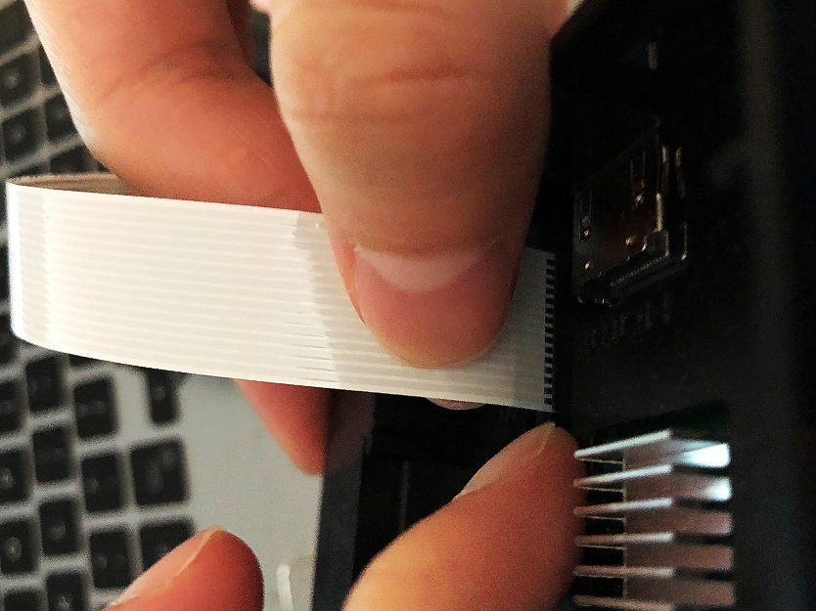

Next the right side too so that both sides are secure:

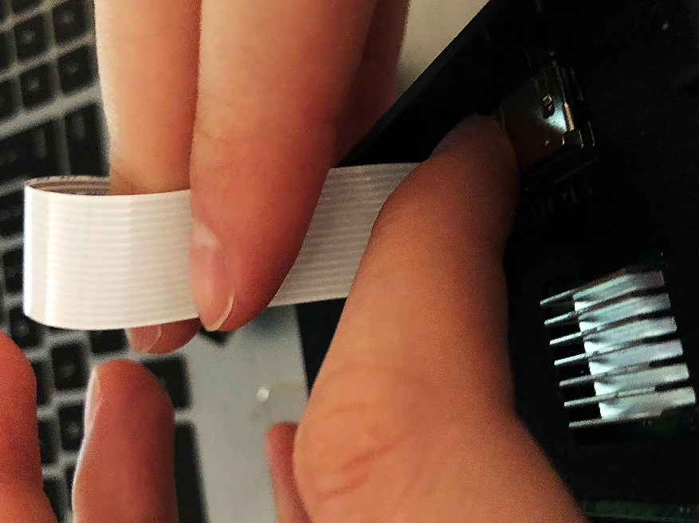

Final product:

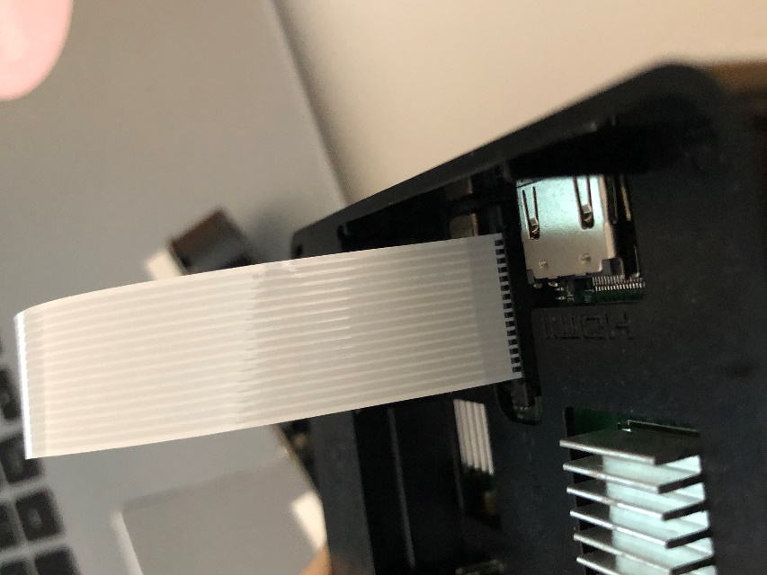

Now we will move to the RPi part. You will have to plug your SD Card into your Pi.

Two ways to get to your RPi:

- Physical Access with Keyboard, Mouse, Monitor and HDMI cable (with a HDMI to VGA if connecting to older monitors)

- SSH or VNC (you would have to enable it, so either way the 1st time you would have to have physical access)

FIRST TIME setting up your RPi would need to put in Country, Timezone, and Language, also choose US keyboard

Then, you can choose to update your password, you can just insert the default “raspberry” for ease of use.

You can also, connect to a Wifi (home for example) to get to the internet.

Also, choose skip if you don’t want it to update the system (this might lead to upgrading of OS)

Now we have all the components connected to access the RPi, I’m gonna go through Adrian’s OpenCV setup which takes approximately more than 4 hrs!

The good thing is that his tutorial shows the time needed for each command ran on the cmd!

We start from the Expand filesystem part:

After that: check with **df -h** command:

Next:

Key points to follow during the whole thing:

-FIRST MAKE SURE YOU READ EVERY LINE IN THE LONG TUTORIAL, AND DO NOT SKIP ANYTHING UNLESS STATED IN HERE, OR DO SOMETHING THAT’S NOT IN THE TUTORIAL.

-Try to type everything instead of copying

-put SUDO in front of every command (sudo can’t be added when making virtual env, also don’t add sudo to “pip install numpy” as it will skip some additional files that needs to be downloaded )

-If a command doesn’t work, try adding sudo in front of it

-DO NOT RUN THE UPDATE AND UPGRADE AS IT WOULD UPGRADE YOUR PI TO THE LATEST OS

-Also I pulled version ~~4.2.0~~ for the OpenCV & open_contrib so it depends what your latest version of OpenCV is (THIS DID NOT WORK OUT WELL, REVERTED BACK TO 3.3.0)

-Adrian recommended running “source ~/.profile” every time a new cmd is opened so rmb to do it so that system variables are setup correctly

- Its an O not 0 for => wget -O opencv.zip https://github.com/Itseez/opencv/archive/3.3.0.zip

-In the section where it ask you to edit the ~/.profile. Once finished editing and saving, do not exit your terminal. Just go ahead and run “source ~/.profile”

-Make sure you choose the right python version for your vir env (python 3 would be a good choice) ONLY do one “sudo mkvirtualenv cv -p python3”

-~~When install Numpy use pip3 instead of pip (“sudo pip3 install numpy”). If the below ERROR is seen when installing Numpy, please USE (“sudo pip3 install numpy –no-cache-dir”)~~

-When installing Numpy in your virtual env, if you’re met with the ERROR: THESE PACKAGES DO NOT MATCH THE HASHES FROM THE REQUIREMENTS FILE….., change your command to “pip install numpy –no-cache-dir” and it should run successfully

THIS IS MOST IMPORTANT:

I would recommend manually typing all this instead of copying it, also make sure you change the opencv version in the command to whatever version you have, also make sure to not forget the two dots at the end after a space

cmake -D CMAKE_BUILD_TYPE=RELEASE \

    -D CMAKE_INSTALL_PREFIX=/usr/local \

    -D INSTALL_PYTHON_EXAMPLES=ON \

    -D OPENCV_EXTRA_MODULES_PATH=~/opencv_contrib-3.3.0/modules \

    -D BUILD_EXAMPLES=ON ..

YOUR RPi WILL MOST LIKELY OVERHEAT, (LIKE MINE), TO PREVENT THAT:

- UNPLUG ANY DEVICES (KEYBOARD FOR SURE, MOUSE ID NEEDED TOO), ALSO THE HDMI AND PLUG IT BACK AFTER MAKING SURE THE RPI IS NOT AS HOT AS BEFORE, JUST FOR THE SAKE FOR LOOKING AT THE PROGRESS

- START BLOWING ON IT (I ACTUALLY DID FOR MINE A FEW TIMES)

- START THE CEILING FAN BEFORE MAKING

- MAKE SURE NOTHING IS COVERING THE PI OR ANYTHING IS UNDERNEATH IT

- TURN ON YOUR COLD AC (ALSO BFR MAKING)

The screen regularly turns black with only the backlight and won’t show anything even if I mouse-clicked. I had to blow on it and it would come back on for some reason

For some reason my cv2.so file was located in the /usr/local/lib/python-3.5/dist-packages/cv2/python-3.5 directory which is weird.

-So when I sym-link I have to put in ln -s /usr/local/lib/python3.5/dist-packages/cv2/python3.5/cv2.so cv2.so into the python3.5 of our virtualenvs (~/.virtualenvs/cv/lib/python3.5/site-packages/)

For some reason, even if I reverted back to compiling and installing opencv 3.3.0, I ended up with the newest opencv 4.2.0 which I failed to install the first try

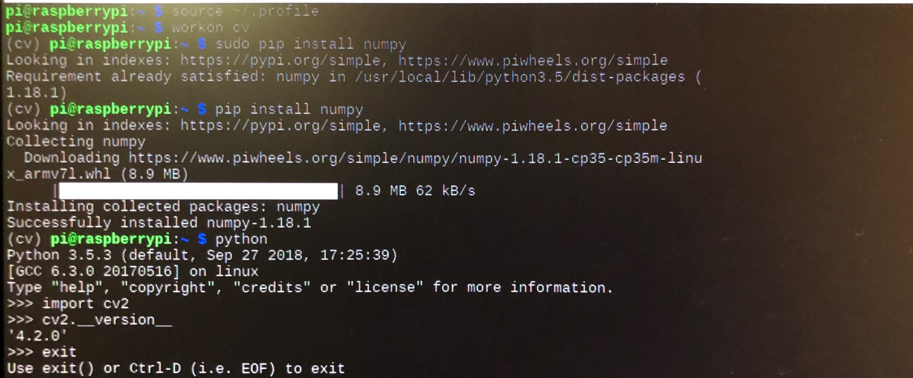

Also, I talked about not putting sudo when installing numpy, I got an ImportError: multiarray not recognized (numpy error) when importing cv2 if you look at the above picture, you can see the difference between adding a sudo for installing numpy and not adding a sudo. Once that’s done, you’ll be able to have what I have above